Prerequisite

1. Open the Application (https://bugasura.io/) in any Browser

Test Steps:

Step 1. Click on Start for Free button.

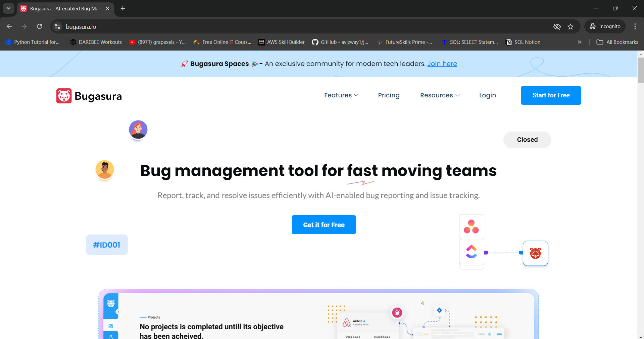

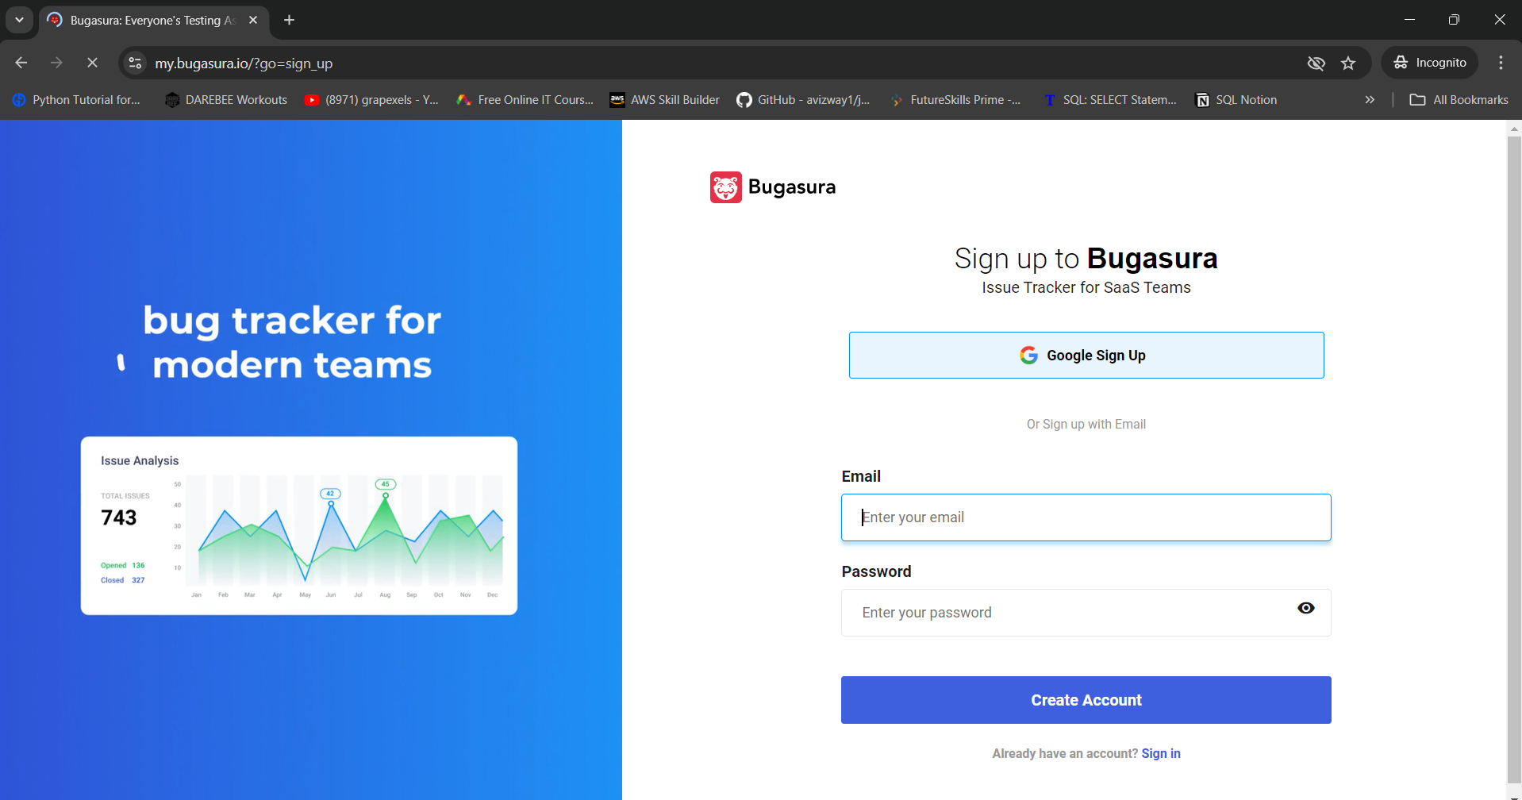

Step 2. Enter new Account Details into the Fields (E-Mail, Password)

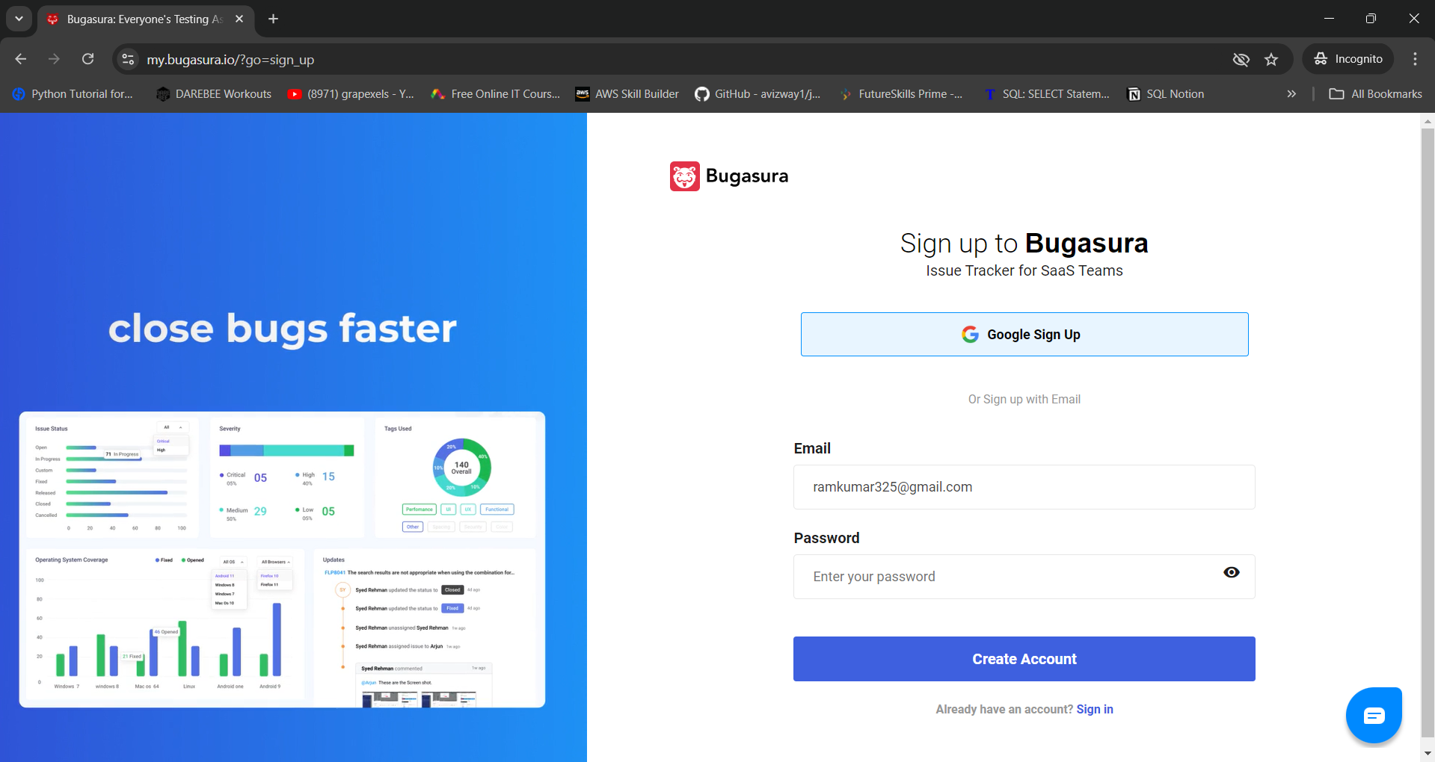

Step 3. Enter a password which is very weak and not matching the Strong Password Policy.

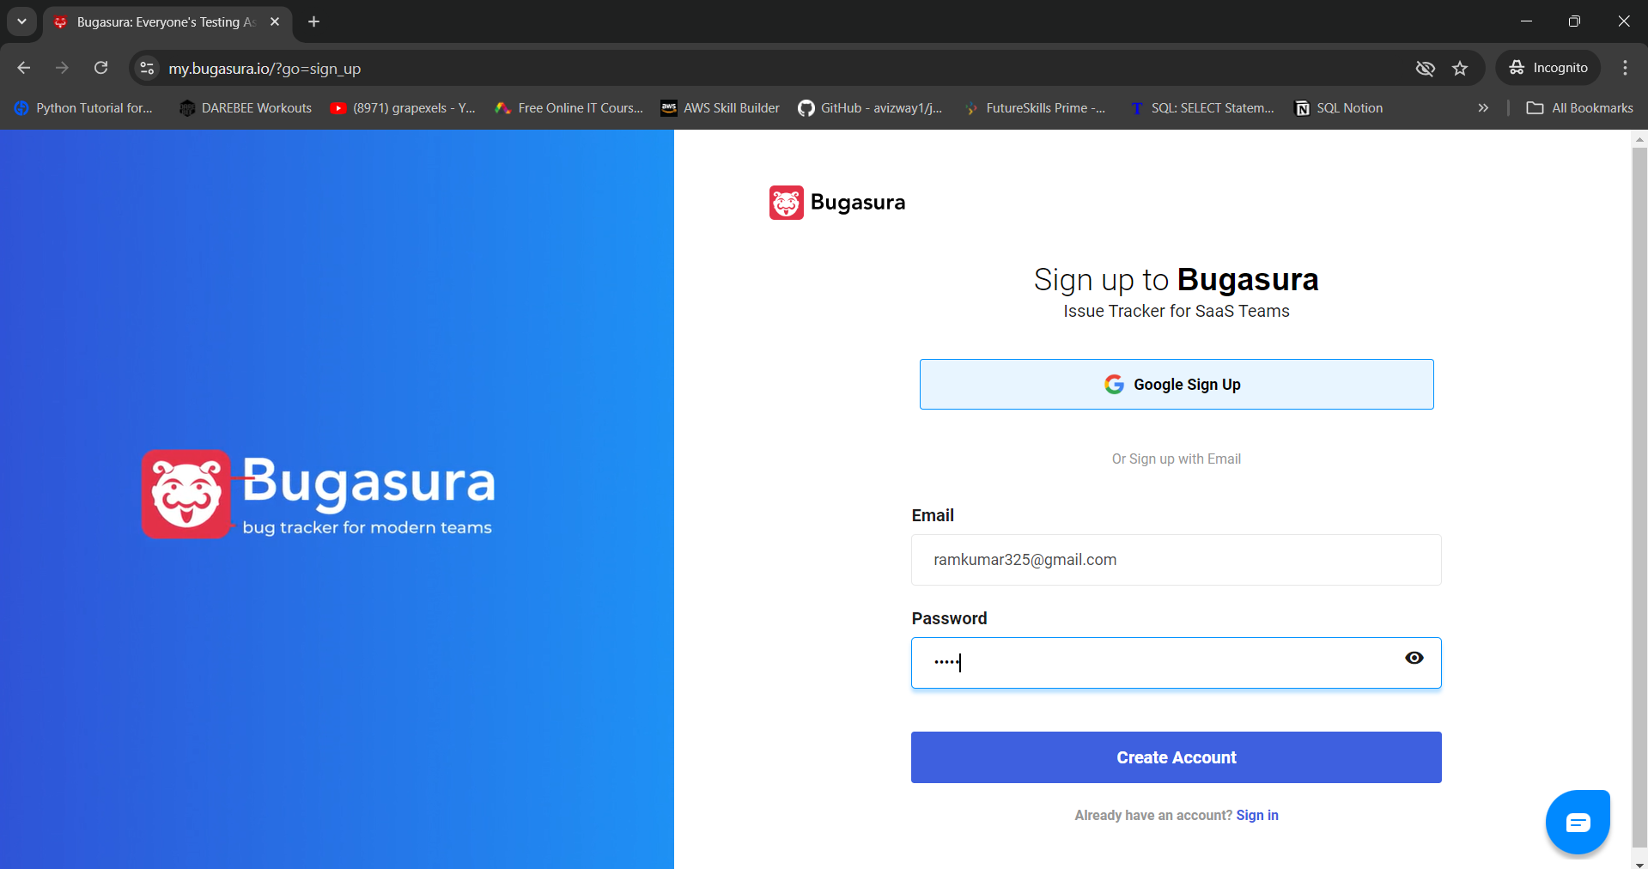

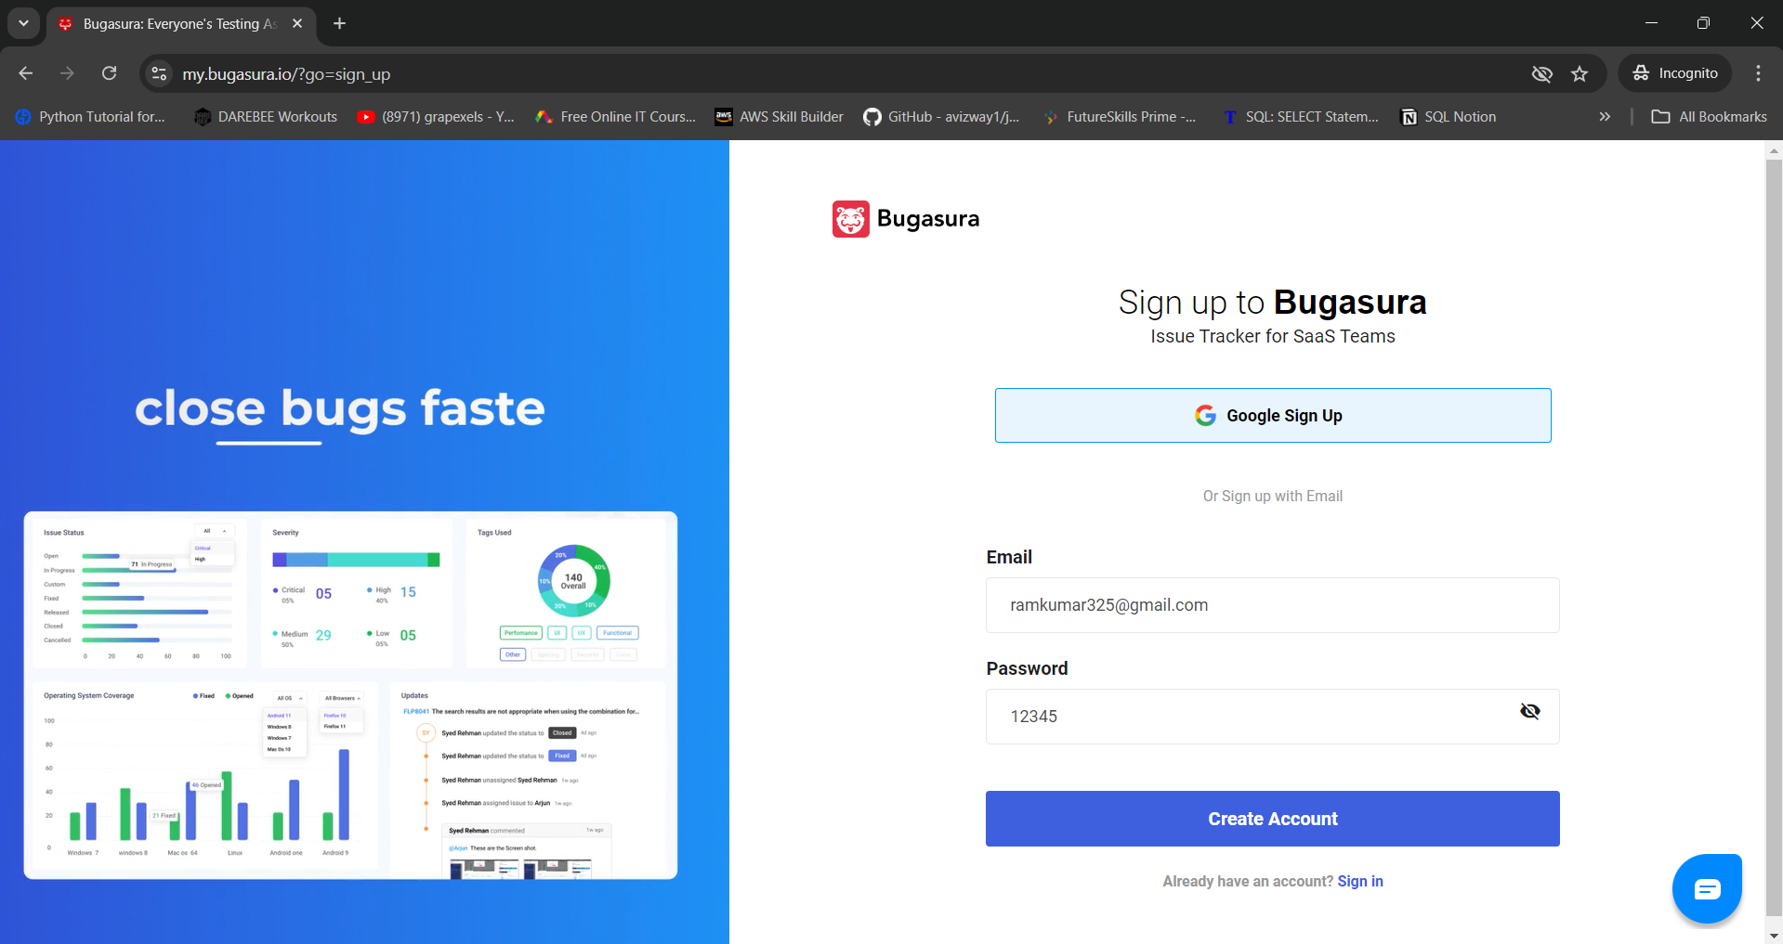

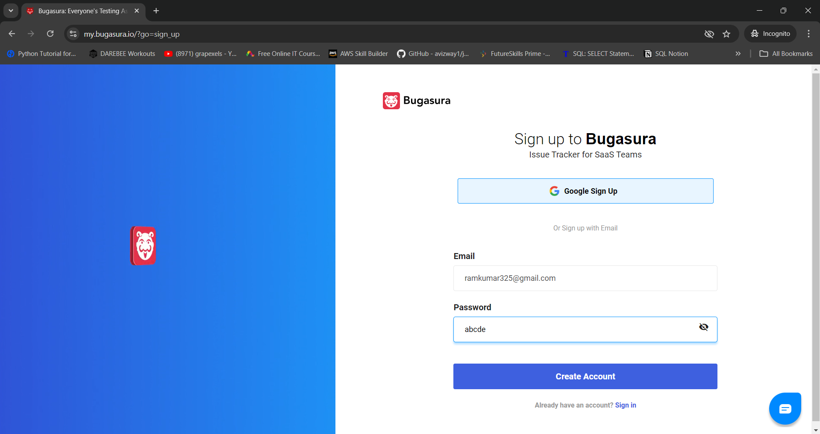

Step 4. Click on Sign In button.

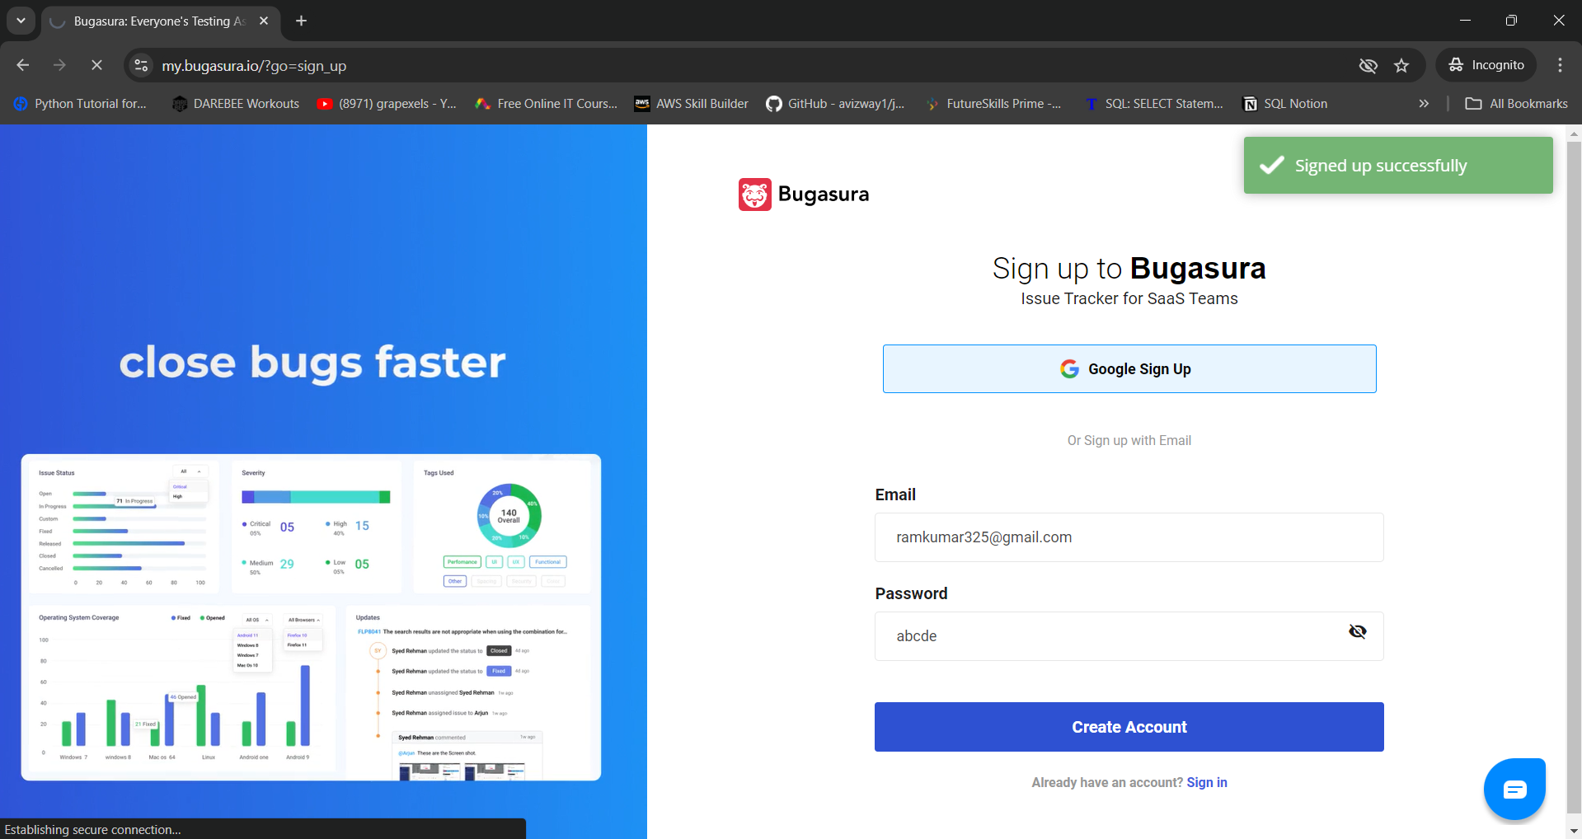

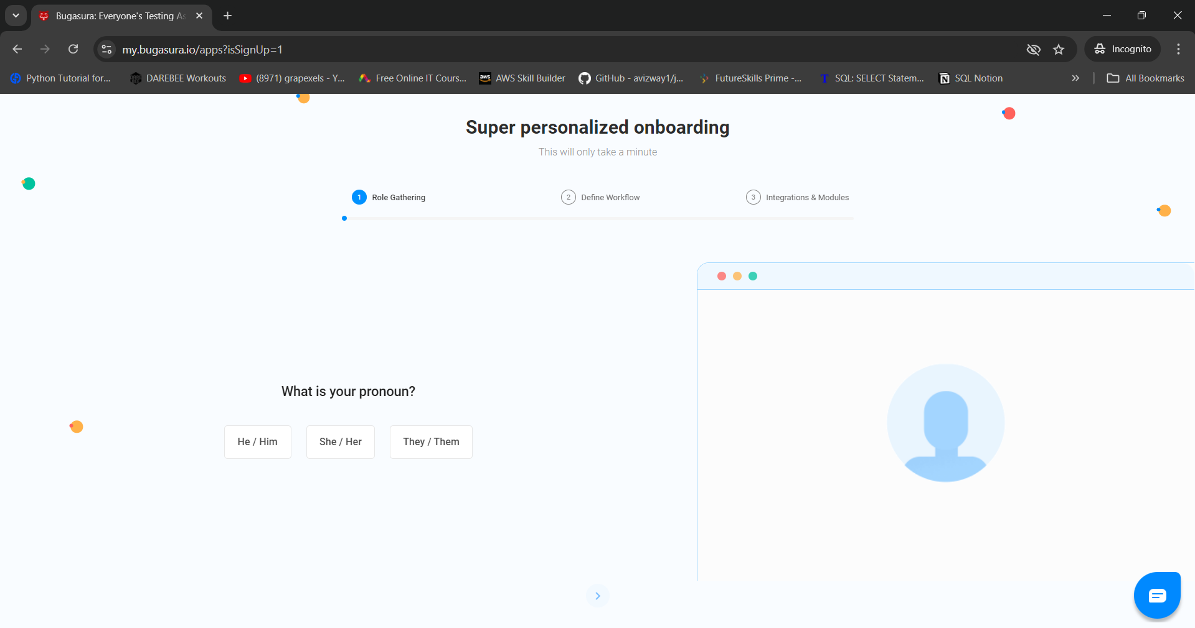

**Actual Result:**

No error message is displayed. Application is accepting the weak password which is entered by the user.

**Expected Result:**

Application should display an error message stating 'Please enter a Strong Password'.